SOFTWARE ENGINEERING CSA1006
MOHAMMED FAREETH S A
192511288

1. Explain Technical Debt
Technical debt is the future cost created when a software team chooses a quick, convenient, or incomplete technical solution instead of implementing the best long-term solution. The idea is similar to financial debt: taking a shortcut may help the organization deliver a feature quickly, but the shortcut creates a future obligation in the form of refactoring, maintenance, defects, slower development, or increased operational risk.
Technical debt is not automatically bad. A deliberate and documented shortcut can be reasonable when a company must release a minimum viable product quickly. The problem occurs when the debt is hidden, unmanaged, or allowed to accumulate. As the system evolves, old design decisions can make every new feature more difficult and expensive.
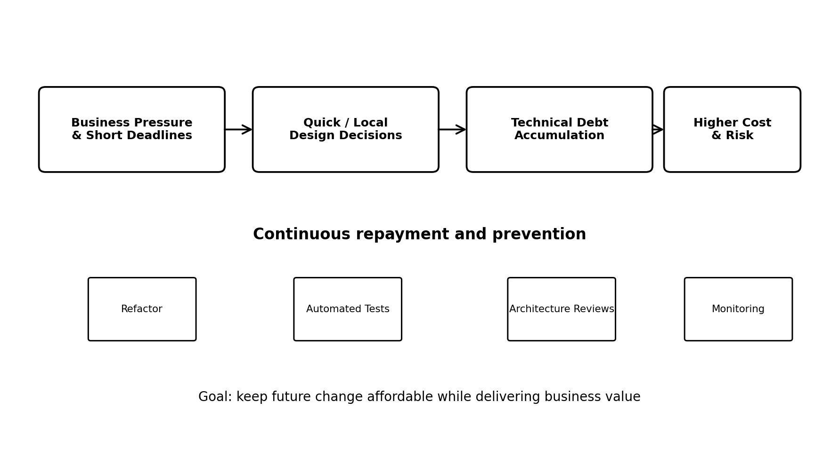
Figure 1. Technical debt accumulation and continuous repayment.

Major Causes of Technical Debt
- Tight deadlines and business pressure: teams may implement the fastest solution to meet a release date.
- Poor architecture or design decisions: tightly coupled modules, unclear interfaces, and weak separation of concerns make future changes difficult.
- Insufficient testing: missing unit, integration, and regression tests allow defects and fragile code to accumulate.
- Lack of refactoring: code that works may remain unchanged even when its structure becomes difficult to maintain.
- Changing requirements: frequent business changes can make earlier assumptions obsolete.
- Inadequate documentation: developers may spend time reverse-engineering the system and may introduce inconsistent fixes.
- Lack of engineering standards: inconsistent coding practices, dependency management, and review processes increase maintenance cost.
- Outdated dependencies and technologies: unsupported libraries can create security, compatibility, and upgrade problems.
- Knowledge concentration: if only one person understands a subsystem, maintenance becomes risky and slow.

How Organizations Can Minimize Technical Debt
- Maintain a visible technical-debt backlog: record the debt, its impact, owner, priority, and estimated effort instead of treating it as invisible work.
- Allocate regular capacity for repayment: reserve part of each sprint or release cycle for refactoring, dependency upgrades, test improvement, and architectural cleanup.
- Use code reviews and coding standards: peer review catches duplicated logic, poor abstractions, security issues, and maintainability problems early.
- Adopt automated testing and CI/CD: automated checks detect regressions and make refactoring safer.
- Prefer simple and modular architecture: low coupling and high cohesion reduce the cost of future change.
- Use architecture decision records: documenting why an important design choice was made makes future evolution more deliberate.
- Monitor software health: metrics such as defect rate, build failures, code complexity, test coverage, and dependency age can reveal growing debt.
- Upgrade dependencies proactively: scheduled upgrades are generally safer than waiting until a library becomes unsupported or incompatible.
- Balance delivery and quality: product planning should consider long-term maintenance cost rather than measuring success only by short-term feature delivery.

Conclusion
Technical debt should be managed as an engineering investment rather than treated as a one-time cleanup task. The most effective organizations make debt visible, prevent unnecessary debt, and continuously repay high-impact debt while the software evolves.

2. AI/ML and Edge Computing in Modern Software Engineering
Artificial Intelligence and Machine Learning (AI/ML) and Edge Computing are changing software engineering by moving systems from purely rule-based, centralized applications toward intelligent, data-driven, distributed systems. AI/ML enables software to learn patterns from data and support prediction or automation, while Edge Computing moves computation closer to where data is generated.
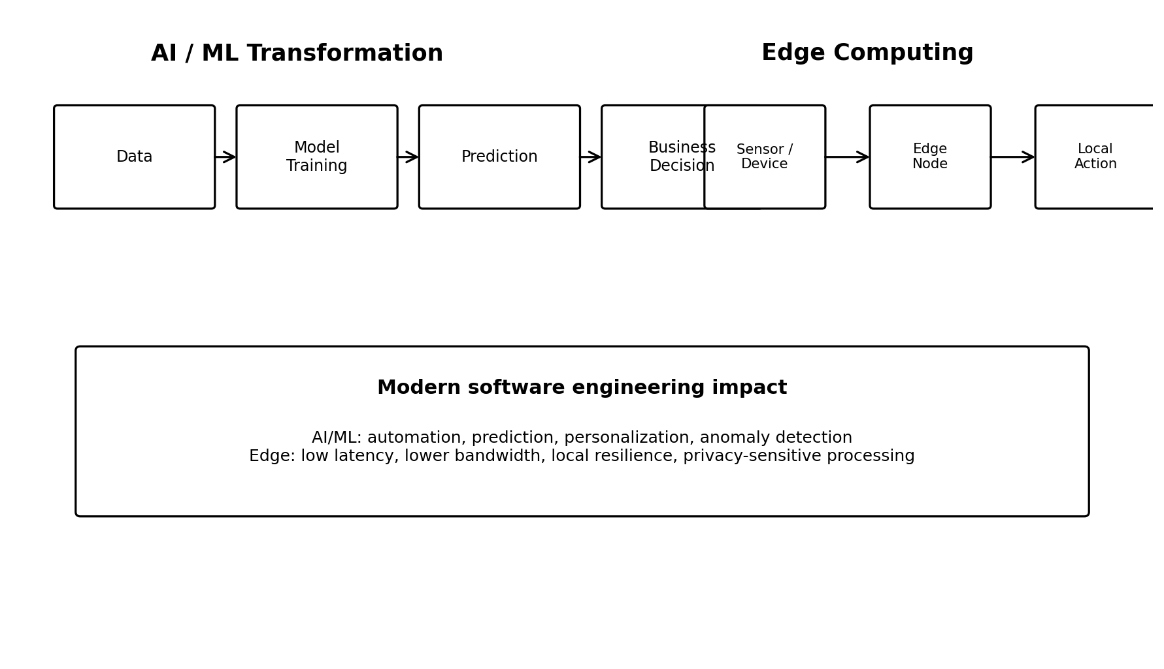
Figure 2. High-level view of AI/ML and Edge Computing transformations.

A. How AI/ML Is Transforming Software Engineering
AI/ML is being used throughout the software lifecycle. During development, AI-assisted tools can help generate code, explain unfamiliar code, detect bugs, suggest tests, summarize requirements, and identify possible security problems. During operation, machine-learning models can detect anomalies, predict failures, personalize user experiences, and optimize resources.
- Intelligent automation: repetitive development and operational tasks can be partially automated.
- Predictive analytics: historical data can be used to predict failures, demand, fraud, or user behavior.
- Automated testing support: AI can help generate test cases and identify unusual inputs.
- Anomaly detection: models can recognize behavior that differs from normal system activity.
- Personalization: applications can recommend content or actions based on user behavior.
- Developer productivity: AI coding assistants can accelerate implementation and debugging while still requiring human review.

Practical AI/ML Example: AI Hiring or Fraud Detection
A practical example is an AI-assisted fraud detection system used by a digital banking platform. The system can learn from historical transactions and assign a risk score to new transactions. For example, an unusual transaction from a new device, unusual location, and abnormal amount can receive a high risk score. The software can then request additional verification or send the transaction for human review. The model should be monitored for false positives, bias, data drift, and security problems.

B. How Edge Computing Is Transforming Software Engineering
In a traditional cloud architecture, devices send most data to a remote cloud service for processing. In Edge Computing, processing is performed on or near the device that generates the data. The cloud can still be used for storage, model training, centralized management, and long-term analytics.
- Lower latency: decisions can be made locally without waiting for a round trip to the cloud.
- Reduced bandwidth: only useful or summarized data needs to be sent to centralized systems.
- Improved resilience: local processing can continue during temporary network failures.
- Privacy support: sensitive data can sometimes be processed locally rather than transmitted.
- Scalable IoT systems: thousands of sensors can perform local filtering before sending data upstream.

Practical Edge Computing Example: Smart Parking
A smart parking system can use sensors or cameras at individual parking spaces. An edge device can process sensor readings locally and determine whether a slot is occupied. Instead of continuously transmitting raw sensor data, the edge device can send compact events such as 'Slot A12 became occupied' to the cloud. The mobile application then receives near-real-time availability information. This reduces network traffic and improves response time.

Combined Impact
AI/ML and Edge Computing can also be combined. For example, an edge device can run a lightweight machine-learning model locally to classify whether a parking slot is occupied. This combination creates an intelligent distributed system in which data is processed close to its source and decisions are made quickly.

3. Case Study – Sustainable DevOps for Cloud Microservices
A company operating dozens of cloud-based microservices may observe that CPU, memory, storage, network traffic, and container counts keep increasing. If resources are provisioned conservatively, many instances remain underutilized. The result is both higher cloud expenditure and unnecessary energy consumption. Sustainable DevOps addresses this problem by treating resource efficiency and environmental impact as engineering concerns alongside reliability, performance, and security.

Practice 1: Right-Sizing and Autoscaling
The first practice is to measure actual resource usage and provision services according to their real workload. CPU and memory requests and limits should be based on observed utilization rather than guesses. Autoscaling can increase capacity during demand peaks and reduce it when demand falls.
- Collect CPU, memory, request-rate, latency, and container utilization metrics.
- Remove consistently idle or oversized instances.
- Use horizontal autoscaling for services whose workload changes over time.
- Use scheduled scaling when traffic patterns are predictable.
- Review resource requests periodically as application behavior changes.
This reduces both wasted infrastructure and cloud cost. A key caution is that aggressive scaling should not violate service-level objectives; scaling policies must be tested against peak traffic and failure scenarios.

Practice 2: Efficient Containers, Workloads, and Infrastructure
Microservices should be packaged efficiently and run on infrastructure that matches their workload. Smaller container images reduce storage and transfer overhead. Unused containers, development environments, old snapshots, unattached disks, and idle load balancers should be identified and removed. Workloads can also be scheduled so that machines are packed efficiently rather than leaving many hosts partially utilized.
- Use lightweight container images and remove unnecessary packages.
- Consolidate workloads when capacity and reliability requirements allow it.
- Shut down non-production environments outside required hours.
- Delete unused storage volumes, snapshots, and test resources.
- Use caching and batching where appropriate to reduce repeated computation and network traffic.

Practice 3: Carbon-Aware Cloud Operations
When workloads are flexible, organizations can consider where and when computation is performed. Carbon-aware operations use information about energy efficiency or carbon intensity to schedule suitable workloads in lower-impact periods or locations, subject to latency, data residency, compliance, and availability constraints.
- Schedule batch processing during lower-impact periods when business requirements permit.
- Choose efficient cloud regions when latency, compliance, and availability requirements are satisfied.
- Separate latency-critical workloads from flexible workloads.
- Track energy or carbon-related metrics together with cloud cost and performance.
- Include sustainability targets in engineering and capacity-planning decisions.
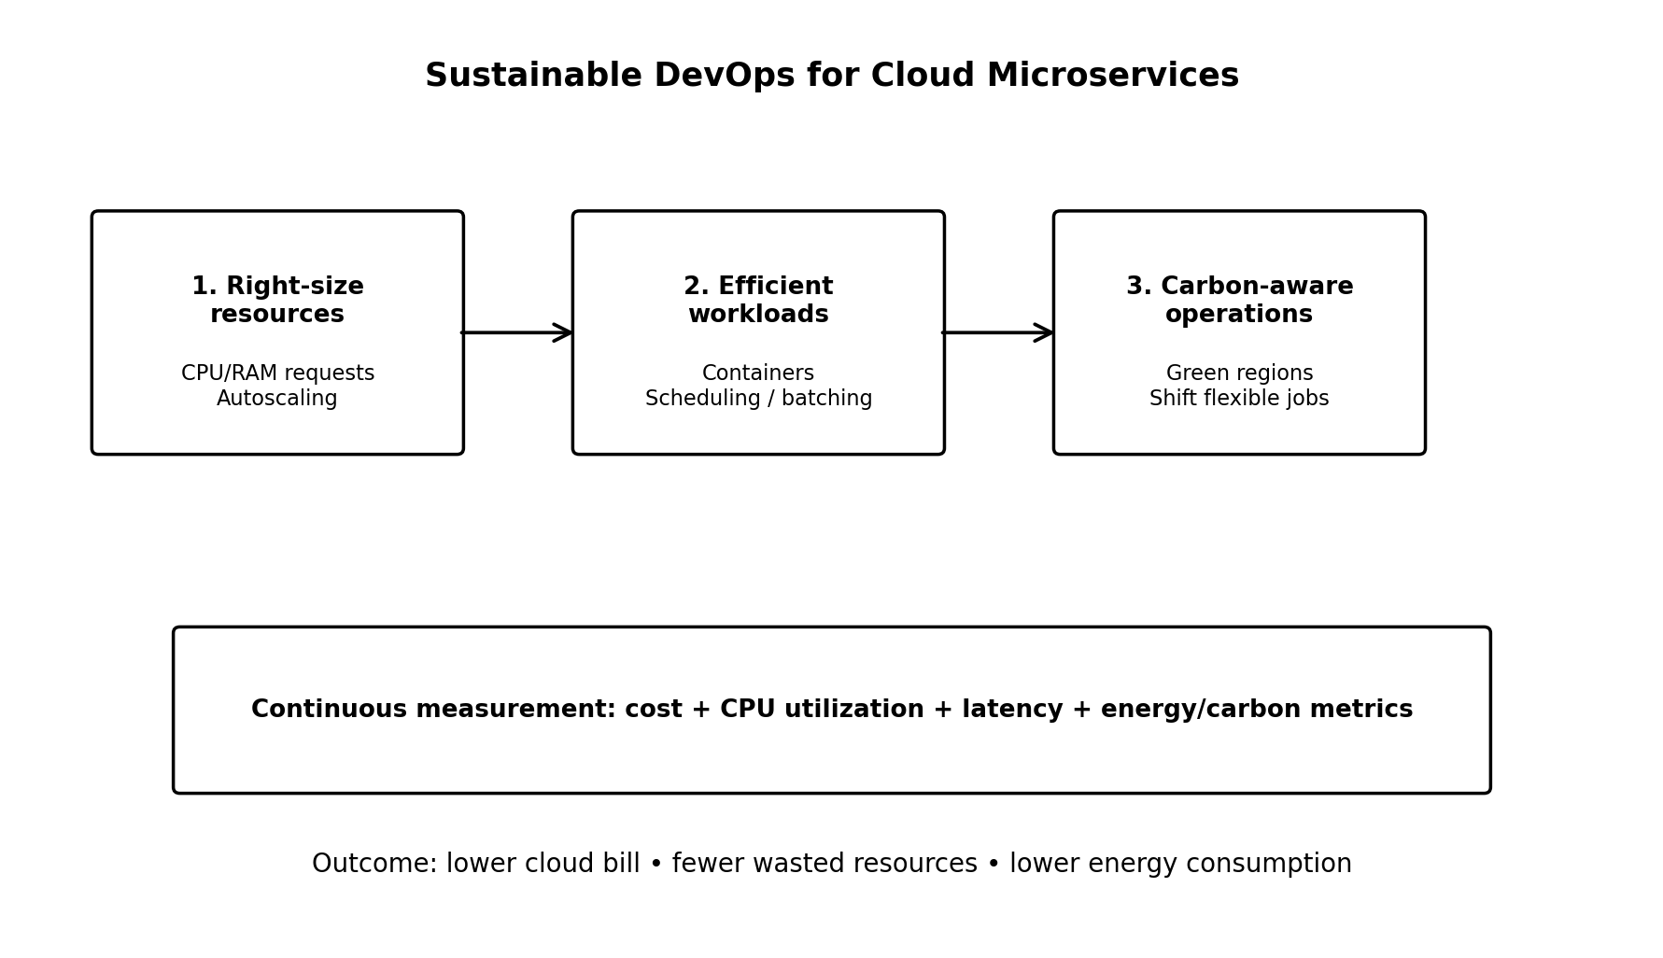
Figure 3. Three sustainable DevOps practices and continuous measurement.

Overall Effect on Energy and Cloud Cost
The three practices work together. Right-sizing prevents over-provisioning, efficient workloads reduce unnecessary computation and infrastructure, and carbon-aware operations reduce environmental impact for workloads that can be moved or delayed. The organization should continuously compare utilization, service performance, cloud cost, and sustainability indicators.
A simple conceptual relationship is:
Cloud Cost ≈ Resource Usage × Unit Price
Energy Consumption ∝ Compute + Storage + Network Activity
These expressions are conceptual rather than exact billing or physical-energy formulas. They illustrate why reducing unnecessary resource usage can simultaneously reduce cloud expenditure and energy demand.

Conclusion
Sustainable DevOps makes environmental efficiency part of normal software engineering. For a cloud microservices company, right-sizing and autoscaling, efficient infrastructure and workloads, and carbon-aware operations provide a practical starting point. The most important requirement is continuous measurement so that sustainability improvements do not compromise availability, security, performance, or user experience.

Answer Summary
Question | Core Concept | Key Takeaway
1. Technical Debt | Short-term shortcuts create future maintenance cost. | Make debt visible, prevent unnecessary debt, and repay high-impact debt continuously.
2. AI/ML + Edge | AI learns from data; Edge processes data near its source. | Together they enable intelligent, low-latency, distributed applications.
3. Sustainable DevOps | Optimize infrastructure, workloads, and workload placement. | Measure utilization and sustainability continuously to reduce waste and cloud cost.

